**REPORT ON COM 528 ASSESSMENT BASED ON CATALOGUE SHOPPING CART SYSTEM**

**STUDENT NAME: DAVID AGBOLADE**

**STUDENT NUMBER: Q14872382**

**INTRODUCTION**

Catalogue Shopping System is a web-based project which is made for remote-shopping or People had to suffer the rush of the market when they went shopping. They used to think hundred times to buy anything having sufficient money for shopping. The problem was the rush; the quarrel at the time of buying the things. But the advancement of technology brought a new way of shopping. The way of shopping was completely changed with the coming of Internet Technology. People must fill a simple form on the internet to place their order on any popular shop or shopping-mall for the thing they want to buy. Now they can place their order from the home. This project entitled “catalogue shopping system” is an implementation of the above description. It means, it implements E-shopping or in other words shopping through the Internet. It lets the user place their order online for any article.

**Features of Project**

1. Clean navigational menu with an In-Site Search and product categories:

To attract consumers, your website should not only be eye-catching but also user-friendly. 25% of consumers abandon the purchase because they find website navigation too complicated.4 that’s why your layout should be transparent, menu sections clearly divided and navigation intuitional. Make sure that the most important call to action – the add to cart button – is always visible. Pay special attention to the organization of your products. Divide them into sections and subsections, preferably in few different ways. The products should be easy to find by brand, product type, and price range. Don’t forget about including an In-Site Search button. It will allow your consumers to find what they are looking for in a few seconds.

2. Detailed product descriptions

No matter how great your products are your customers won’t know that unless you provide them with proper descriptions. This is one of the most important and surprisingly one of the most often neglected online shop features. So, remember: every product must have a clear and extensive description! Especially if we talk about items that are like each other such as laptops.

**Project description**

An **online catalogue food shopping system** **JAVA JSP MYSQL** is a web-based application that stimulates the foodies (customers) to put food orders through internet by locating their favourite restaurant or nearest one.  This application is based on the **JAVA, JSP (Java Server Page), MYSQL** platform.

The **online catalogue food shopping system** **JAVA JSP MYSQL** provides convenience for the customers. It overcomes the disadvantages of the traditional queuing system. This system increases the takeaway of foods than visitors. Therefore, this system enhances the speed and standardization of taking the order from the customer. **The online catalogue food shopping system JAVA JSP MYSQL** set up menu and the customers easily places the order with a simple mouse click. This system allows the user to select the desired food items from the displayed menu. The use r’s details are maintained confidential because it maintains a separate account for each user. An id and password are provided for each user. Therefore, it provides a more secured ordering.

**Modules and their requirements: -**

**User Module:**

* Login
* Registration
* View Menu
* Order
* Order History
* Feedback

**Admin Module:**

* Login
* View Menu
* Add Menu Item
* Delete Menu
* View All User
* View All Order
* View All Feedbacks
* View Specific User all Order

**DESIGN**

**Model Used**

**Waterfall Model**

The waterfall model is a sequential design process, often used in software development processes, in which progress is seen as flowing steadily downwards (like a waterfall) through the phases of Conception, Initiation, Analysis, Design, Coding, Testing, Implementation, and Maintenance.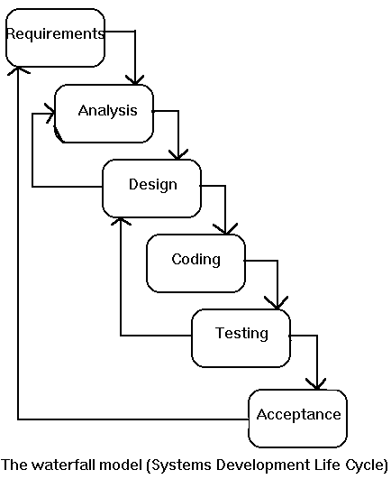

In waterfall model, the following phases are followed in order:

1. Requirement’s specification
2. Feasibility Study
3. Design & Coding
4. Integration & Testing
5. Implementation
6. Maintenance

**Requirement Analysis & Definition**: All possible requirements of the system to be developed are captured in this phase. Requirements are set of functionalities and constraints that the end-user (who will be using the system) expects from the system. The requirements are gathered from the end-user by consultation, these requirements are analyzed for their validity and the possibility of incorporating the requirements in the system to be development is also studied. Finally, a Requirement Specification document is created which serves the purpose of guideline for the next phase of the model.

**System & Software Design**: Before a starting for actual coding, it is highly important to understand what we are going to create and what it should look like? The requirement specifications from first phase are studied in this phase and system design is prepared. System Design helps in specifying hardware and system requirements and also helps in defining overall system architecture. The system design specifications serve as input for the next phase of the model.

**Implementation & Unit Testing**: On receiving system design documents, the work is divided in modules/units and actual coding is started. The system is first developed in small programs called units, which are integrated in the next phase. Each unit is developed and tested for its functionality; this is referred to as Unit Testing. Unit testing mainly verifies if the modules/units meet their specifications.

**Integration & System Testing**: As specified above, the system is first divided in units which are developed and tested for their functionalities. These units are integrated into a complete system during Integration phase and tested to check if all modules/units coordinate between each other and the system behaves as per the specifications. After successfully testing the software, it is delivered to the customer.

**Operations & Maintenance**: This phase of "The Waterfall Model" is virtually never-ending phase (Very long). Generally, problems with the system developed (which are not found during the development life cycle) come up after its practical use starts, so the issues related to the system are solved after deployment of the system. Not all the problems come in picture directly, but they arise time to time and needs to be solved; hence this process is referred as Maintenance.

**Advantages**

The advantage of waterfall development is that it allows for departmentalization and managerial control. A schedule can be set with deadlines for each stage of development and a product can proceed through the development process like a car in a carwash, and theoretically, be delivered on time. Development moves from concept, through design, implementation, testing, installation, troubleshooting, and ends up at operation and maintenance. Each phase of development proceeds in strict order, without any overlapping or iterative steps.

**Disadvantages**

The disadvantage of waterfall development is that it does not allow for much reflection or revision. Once an application is in the testing stage, it is very difficult to go back and change something that was not well-thought out in the concept stage. Alternatives to the waterfall model include joint application development (JAD), rapid application development (RAD), synch and stabilize, build and fix, and the spiral model.

**Data Flow Diagrams**

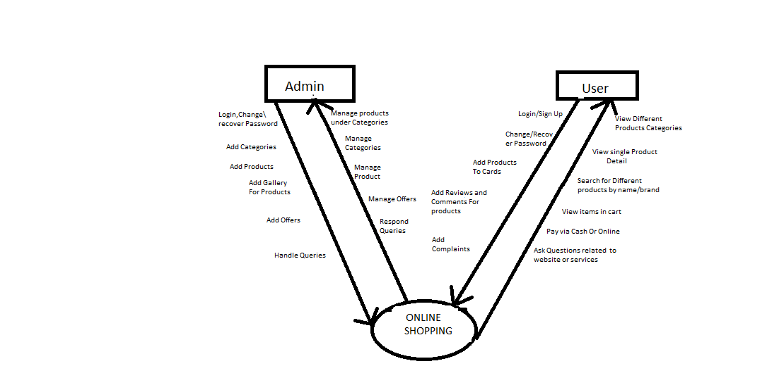

**ADMIN LEVEL 1**

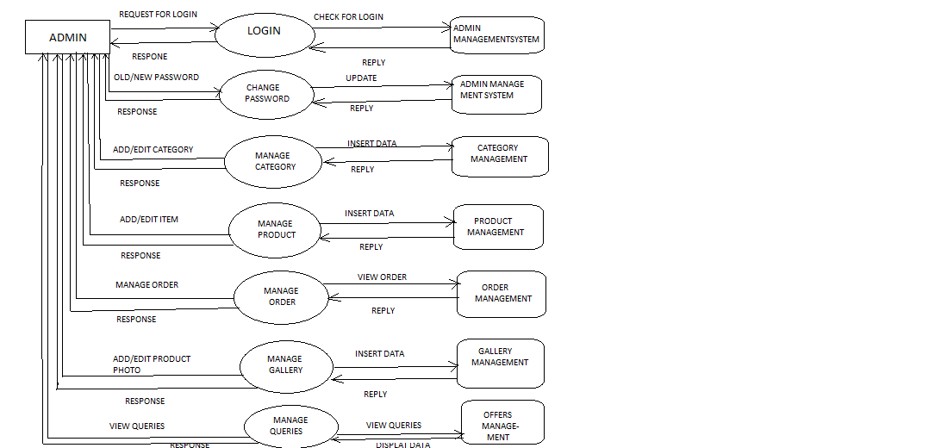

**ADMIN LEVEL 2**

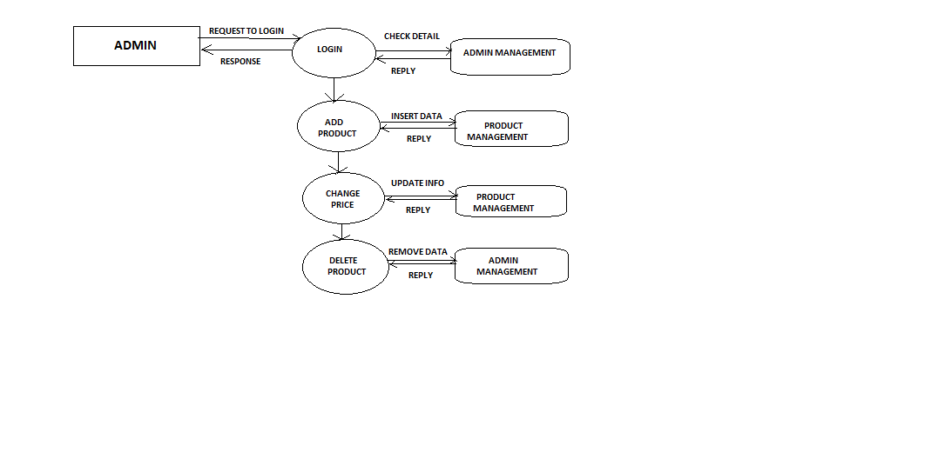**USER LEVEL 1**

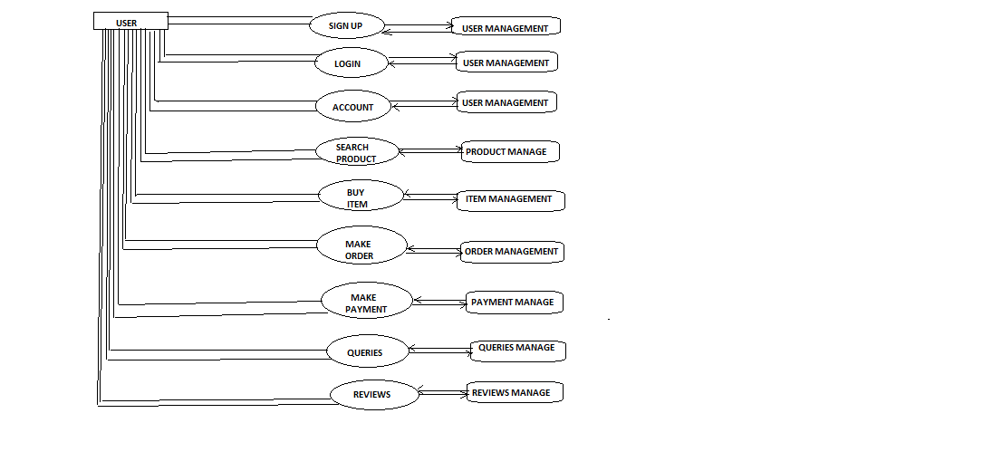

**USER LEVEL 2**

**REFERENCES**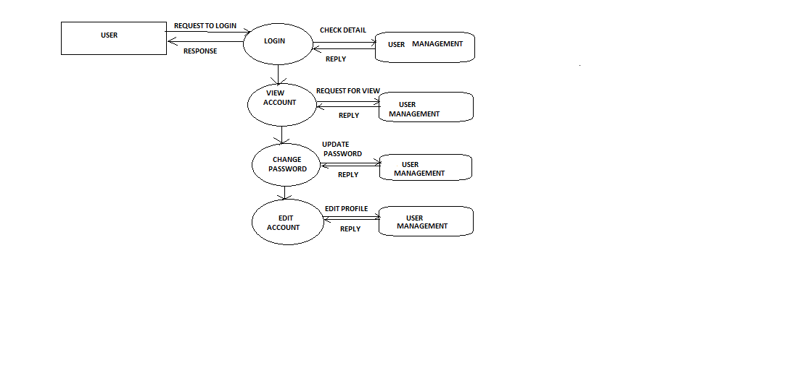

**REFERENCES**

* Phillip Webb, S., 2022. *Spring Boot Reference Documentation*. [online] Docs.spring.io. Available at: <https://docs.spring.io/spring-boot/docs/2.4.2/reference/htmlsingle/#boot-features-developing-web-applications> [Accessed 3 January 2022].
* Sierra, K. and Bates, B., 2008. *SCJP Sun certified programmer for Java 6 study guide*. New York: McGraw-Hill. [Accessed 19 December 2021]
* Stephane Nicoll, S., 2022. *Spring Boot Maven Plugin Documentation*. [online] Docs.spring.io. Available at: <https://docs.spring.io/spring-boot/docs/2.4.2/maven-plugin/reference/htmlsingle/> [Accessed 4 January 2022].